Assignment 3

Q1. Set up a network with router in GUI and CLI.
1. Set up a network with router in GUI
- Create one router, two switches, and ten PCs in Cisco Packet Tracer.
- Connect the PCs to the switches and connect both switches to the router using Copper Straight-Through cables.
- Configure the router interfaces and assign IP addresses through the GUI.
- Configure the IP addresses, subnet masks, and default gateways of all PCs.
- Test communication between PCs using Simple PDU in Simulation Mode.

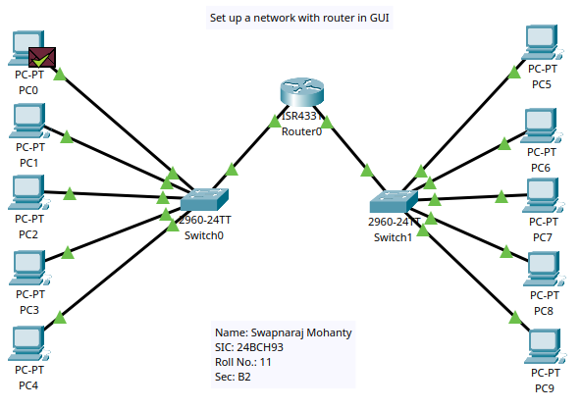

2. Set up a network with router in CLI
- Create one router, two switches, and ten PCs in Cisco Packet Tracer.
- Connect the PCs to the switches and connect both switches to the router using Copper Straight-Through cables.
- Configure the router interfaces using CLI commands and assign IP addresses.
- Configure the IP addresses, subnet masks, and default gateways of all PCs.
- Test communication between PCs using Simple PDU in Simulation Mode.

Router>enable
Router#configure terminal
Enter configuration commands, one per line. End with CNTL/Z.
Router(config)#interface GigabitEthernet0/0/0
Router(config-if)#ip address 192.168.10.1 255.255.255.0
Router(config-if)#no shutdown

Router(config-if)#
%LINK-5-CHANGED: Interface GigabitEthernet0/0/0, changed state to up

%LINEPROTO-5-UPDOWN: Line protocol on Interface GigabitEthernet0/0/0, changed state to up
exit
Router(config)#interface GigabitEthernet0/0/1
Router(config-if)#ip address 192.168.11.1 255.255.255.0
Router(config-if)#no shutdown

Router(config-if)#
%LINK-5-CHANGED: Interface GigabitEthernet0/0/1, changed state to up

%LINEPROTO-5-UPDOWN: Line protocol on Interface GigabitEthernet0/0/1, changed state to up
exit
Router(config)#exit
Router#
%SYS-5-CONFIG_I: Configured from console by console
Exit

